**EXPERIMENT NO.1**

**BY- Gatik Veer**

**Roll N.o. - 2110990493**

**AIM:** Setting up Git Client

**GIT Installation**: Click the link below to download git client for windows -

<https://git-scm.com/download/win>

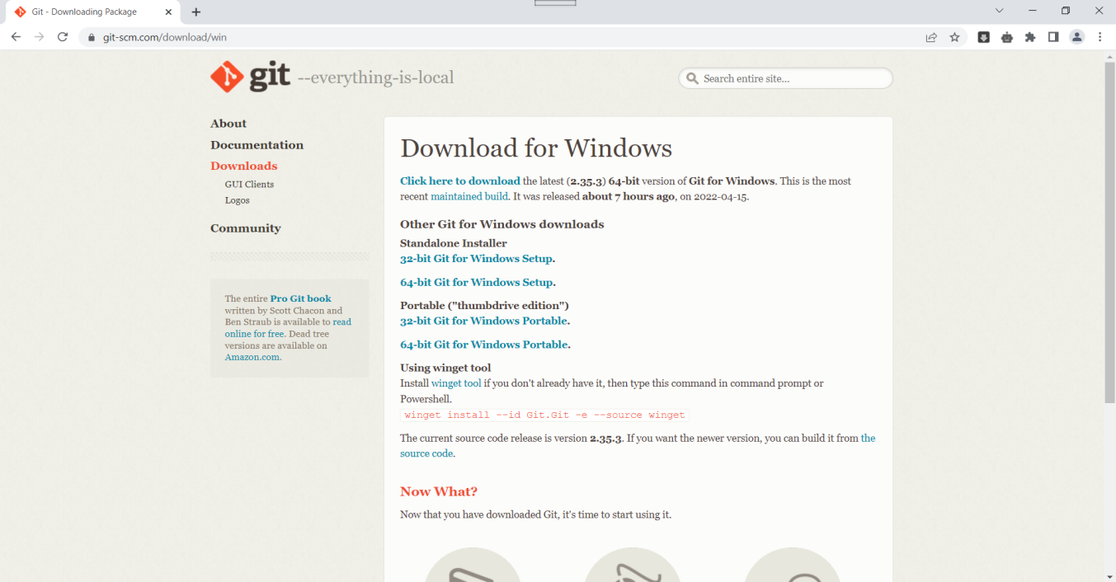

* Choose the operating system which suits your device . I'll choose the 64-bit Git for Windows setup.
* Then, open the Git in Download folder and the following window will appear. Click on Next.

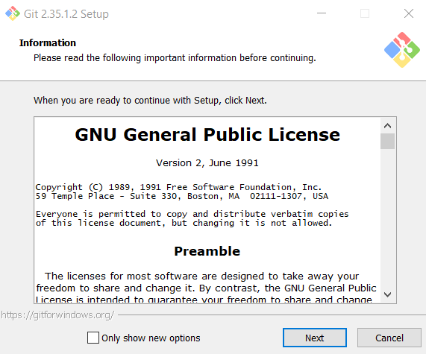

* Continue clicking next without changing any of the default options selected until you reach the following window.

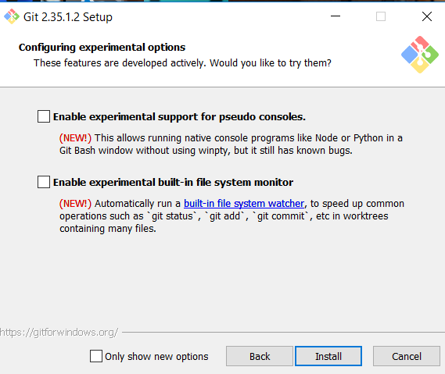

* Now click on install option.
* After the installation of git we have to setup a GitHub account.